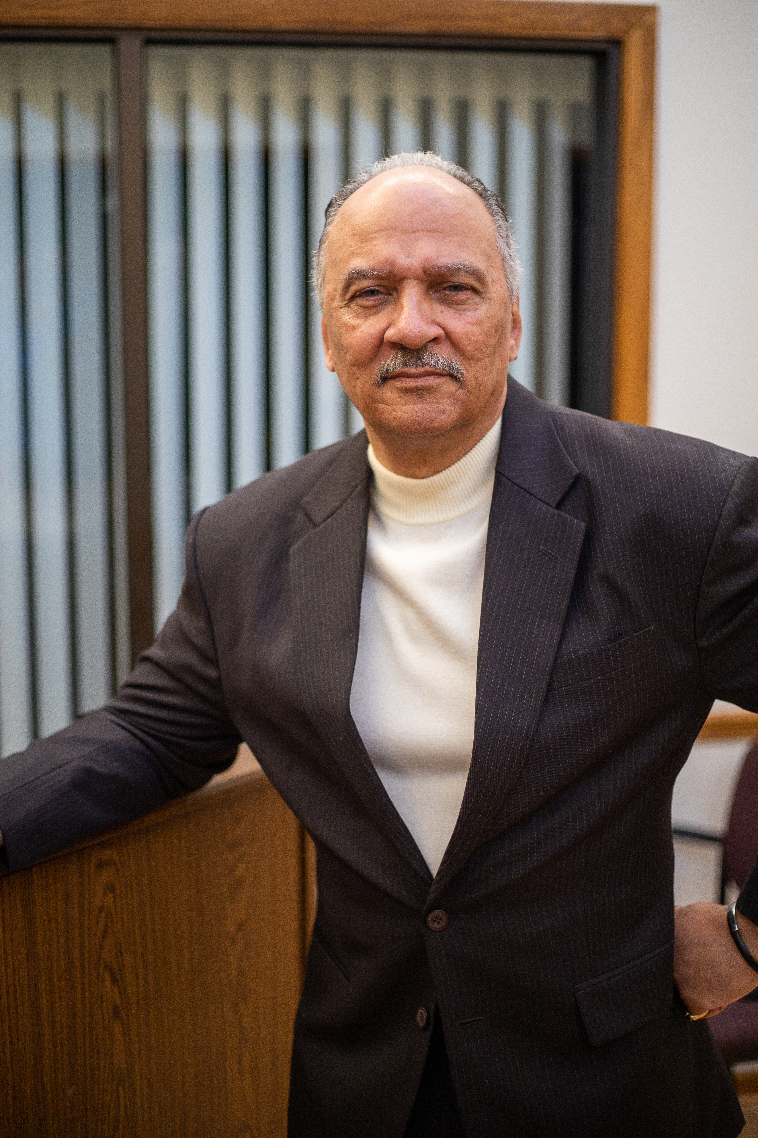

Black Men Are Hurting?
Join me, and other like minded adult black men to an event that could change your life. It is my plan to bring black men from all age groups to join in a discussion about the negative labels attached to us far too long. I will assist you in identifying these character traits by discovering resolves that prevent us from reclaiming our rightful place in society, in the community, and within our own families.

Location & Date Information:
The date, depending on the virus situation, will be June 28, 2020, at 3:00p, at the Destiny Business Centre, 4137 Sauk Trail, Richton Park Illinois. There will be no charge to this introductory event based on interest. If the interest is well-received, further events will be scheduled for $25.00 per participant.
Host: Dr. Ronald Alston, PhD., Behavioral Psychologist
Contact DBC Offices @ 708-377-3096 to reserve your place.

